Pre-Calculus Syllabus

Mr. Frenkel
E-mail: jefferyfrenkel@hasd.org
779-7900 ext. 17117
Website: http://www.hasd.org/faculty/jefferyfrenkel/index.cfm

Textbook
Advanced Mathematical Concepts by Glencoe.

Standards Based Grading
During the semester, I’ll grade your formative and summative assessments using standards-based grading using the rubric below. Each learning target (see appendix A) will receive a score using the decaying average grading calculation, which puts the weight on the most recent assessment.

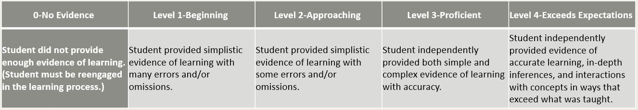

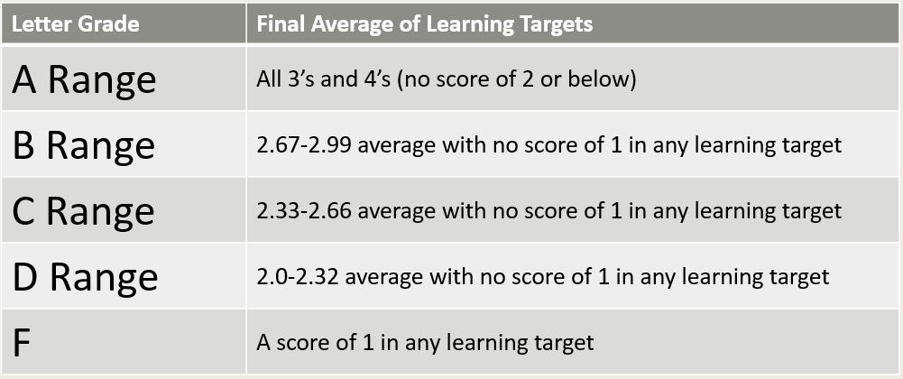

A cumulative exam will be given at the end of the semester. Performance on the final may result in a +/- at teacher discretion, or the grade may remain the same. Appropriate cutoffs will be determined by the PLC team and shared with the students prior to taking the final exam. *In addition, if a student does exceptionally well on the final, a jump in letter bands may occur (ie: if a student is earning a B and retained over 85% of the material from the semester on the final, they may earn an A- overall). Similiarly, if a student does not retain a minimum amount of material on the final, his/her grade may go down a letter band (ie: if they are earning a B and didn’t retain at least 35% of the material from the semester on the final, they may earn a C+).

Materials Needed
You will need a textbook, three-ring notebook, scientific calculator, and pencils. You are expected to bring your book, calculator and other materials to class every day.

Classroom Rules

Every student has a right to an education. Everyone must respect the right of each student to learn as well as the right of the teacher to teach. Therefore, each student shall conduct himself/herself in a courteous manner appropriate in a learning environment. I expect students to be mature, responsible, honest, courteous, and cooperative. There are NO cell phones, iPods, or other music devices out in class while I am teaching.

Everyone should be successful in this class if we all do our jobs. My task is to present the material and answer your questions. Your job is to complete the homework and ask questions when you don’t understand. If you feel you are not understanding the material and need additional help ask me to request you for ELT (extended learning time).

Rules specific to my classroom are:
- Be considerate of others…inappropriate language will not be tolerated
- Be mature and responsible about your education
- Be in class and ready to go when the bell rings
- If you need to use the restroom or go to your locker you must leave your cell phone in the classroom

Academic Integrity
- Cell phones and all electronic devices will be placed in the plastic tub on the table for formatives and summatives. They will remain there until everyone has completed the quiz or test. If you feel uncomfortable placing your things in the tub on the desk, please leave them in your locker. I will not be responsible for lost or damaged materials.
- Students caught cheating will be sent to an administrator for disciplinary action and be reassessed on that assignment at a later date.

Tardies
You should be in class in your desk when the bell rings. This shows you are ready and want to learn. If you come in late you are being disrespectful to those who want to learn and the teacher. If you accumulate three tardies you will be given a major referral.

Homework/Class Work
You may be able to finish some of your assignments in class, provided you are working hard in class. Any work that is assigned and not finished in class is considered homework.

Notebooks
To guide you to success in this class you will be required to keep a notebook. All students will need a 3-ring binder or notebook and must bring it to class every day. In this notebook you will keep notes, definitions, and examples that I will give you in class. A well-organized, neat, and complete notebook will help you achieve success in this class!

Make-up Work
If you are absent it is your responsibility to find out what you missed, this includes assigned work as well as any entries made in our notebooks on that day. If you know in advance you will be absent (vacation or field trip for example) you should get the assignments ahead of time.

*Instructor Discretion: The instructor has the right to make any exceptions to policies, guidelines, and/or expectations throughout the term as (s)he feels necessary.

Mathematics Department Assessment Retake Policy

Retake Assessments:

Students will be able to retake any or all the learning targets that were assessed in formative and summative assessments. To retake a learning target, the student must talk to their teacher and create a plan to prepare for the retake. This plan should include elements from both of the following:

- Show evidence of original learning from before the assessment (homework, reviews, etc.).
- Show evidence of the re-learning after the assessment (corrected assessment, retake ticket, etc.).
The deadline to retake learning targets from formative assessments is prior to the summative assessment. The deadline to retake learning targets from summative assessments is prior to the next summative assessment. If circumstances require a longer retake timeline, a conference between the student and teacher should take place. All retakes from 3rd quarter must be completed before the start of 4th quarter. Students will not be allowed to retake any “2s” from the 3rd quarter once 4th quarter begins.

Some Study Tips:
-Don’t fall behind. Mathematics is a “ladder” subject. New topics build on already-covered material. Cramming won’t work.
-Be prepared. If you review the text ahead of class, then you will better grasp the material that is covered in class.
-Turn off your device. Focus on learning. More and more states are passing laws against “distracted” driving (e.g., driving while texting), recognizing that people can’t focus on driving while staring at a smartphone. The same goes for math class: you can’t learn math while staring at a smartphone--don’t be a distracted learner. Listen attentively, and participate, in class.
-Keep good notes. You learn, in part, by “touching” the same material in different ways: by listening; by writing down what is said; by working out problems (and persevering if you don’t understand a problem when you first attempt it); by asking questions; by explaining concepts to others.
-Do your homework. You get better at sports, music, video games, skateboarding . . . you name it . . . by practicing. Over and over again. The same goes for mathematics.
-Show your work (on homework and assessments): I can more easily figure out what you did wrong if you write down how you first worked the problem.
-Begin to learn to think independently. In a few short years, others (e.g., your boss; your college professors; your customers; etc.) will expect you to be able to figure out and solve problems without someone first showing you how.
-Ask questions when you don’t know. Get help when you need it!

Appendix A:
The following learning targets will be assessed throughout the school year.

Semester 2:

- LT38: I can find values using the graph of trigonometric functions given angles in radians.
- LT39: I can write trigonometric equations given amplitude, period, phase shift, and vertical shift.
- LT40: I can graph the tangent, cotangent, secant, cosecant functions and perform transformations of amplitude, period, phase shift, and vertical shift.
- LT41: I can find principal values of inverse trigonometric functions.
- LT42: I can use the reciprocal, quotient and Pythagorean identities to solve problems and prove other identities.
- LT43: I can use the sum and difference identities to find exact values and prove other identities.
- LT44: I can use the double angle and half-angle identities to find exact values and prove other identities.
- LT45: I can solve trigonometric equations giving solutions as principle values, first rotation values, or all real values.
- LT46: I can add, subtract, multiply, and find the magnitude of vectors algebraically.
- LT47: I can find direction and magnitude of a resultant vector.
- LT48: I can write vector and parametric equations of lines.
- LT49: I can find initial horizontal and vertical velocity.
- LT50: I can prove geometric relationships among points and lines using the distance and slope formulas.
- LT51: I can graph circles, ellipses, hyperbolas, and parabolas; and determine key characteristics of each.
- LT52: I can write the standard form equations for circles, ellipses, hyperbolas, and parabolas.
- LT53: I can use properties of exponents to simplify expressions and solve equations.
- LT54: I can solve application problems involving exponential growth and decay.
- LT55: I can graph exponential functions and describe any transformations that occur.
- LT56: I can use properties of logarithms to simply expressions and solve equations.
- LT57: I can use common and natural logarithms to simplify expressions and solve equations and inequalities.
- LT58: I can solve application problems involving common and natural logarithmic functions.

Appendix B:
The following are schoolwide behavioral learning targets that will be emphasized and expected during the year.

United
A. S1: Students will communicate and collaborate with others to accomplish tasks and develop solutions to problems and opportunities.
A.S1.a. Learning Target: I can effectively work collaboratively with others.
A.S1.b. Learning Target: I can communicate appropriate thoughts and feelings using verbal and non-verbal language.
Respectful
B. S1: Students will identify and apply employability skills.
B.S1.a. Learning Target: I can identify and demonstrate positive work behaviors and personal qualities needed to be employable.
B.S1.b Learning Target: I can evaluate how self-discipline, self-worth, positive attitude, and integrity displayed in a situation affects success.
B.S1.c. Learning Target: I can manage my roles in school responsibly to balance them with other life roles and responsibilities.
B. S2: Students will use technology appropriately to further their learning.
B.S2.a. Learning Target: I can use technology to communicate respectfully with others.
B.S2.b. Learning Target: I can use technology to promote my academic success by creating unique and original work, citing my sources.
B.S2.c. Learning Target: I can use technology to promote my academic success by using online resources that support my learning and avoid technology that may distract from learning.
Accountable
C. S1: Students will formulate and defend judgements and decisions by employing critical thinking
C.S1.a. Learning Target: I can defend an idea, judgement, or argument with evidence and rationale.
C. S1.b. Learning Target: I can formulate an idea and defend it using available information and resources, personal knowledge, and my experience.
C .S2: Students will approach new learning with flexibility and accountability.
C.S2.a. Learning Target: I can be flexible and adaptable when faced with a challenge.
C.S2.b. Learning Target: I can approach new learning with a growth mindset.

